Project Approach Document

1. Project Overview

Project Title: Global Tourism Performance & Revenue Optimization Analysis.
Domain: Travel and Tourism.
Data Volume: 5000+ records (Meeting the 1k-5k row mentor requirement).
Primary Goal: To apply data storytelling and visualization to identify high-performing tourism segments and provide actionable growth recommendations.
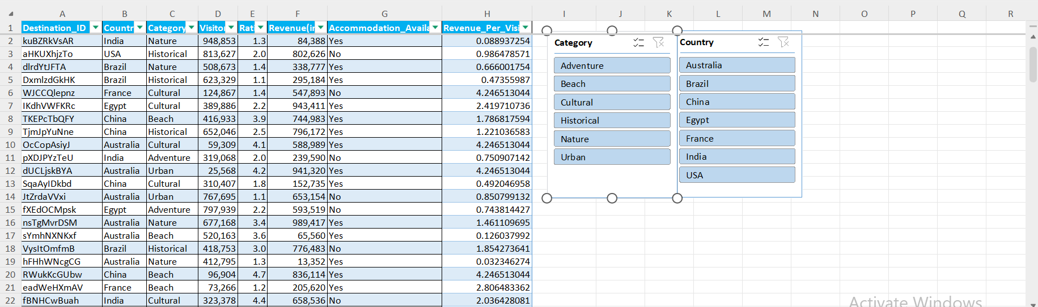
2. Team Roles & Responsibilities

To ensure efficient project execution, the team is organized as follows:

Rahul Pandey
- Defining project objectives and business metrics.
- Overseeing the end-to-end data cleaning process and final data validation.
- Compiling the final 20-slide presentation deck.

Venkatesh
- Managing data collection and integration into the Excel workbook.
- Executing data cleaning tasks (removing duplicates, handling missing values).
- Building Pivot Tables for data summarization.
- Find all the mathemathical operation using Central tendency and Co-efficient
Nisarga
- Designing the interactive dashboard with slicers and filters.
- Selecting appropriate chart types for storytelling (Bar, Pie, Scatter).
- Ensuring the visual narrative aligns with the business metrics.

3. Business Metrics & Research Questions
As per the requirement for 5+ metrics, this project will answer:

Revenue Contribution: Which tourism category (Nature, Beach, Historical) generates the highest total revenue?

Visitor Density: Which countries are the market leaders in terms of total visitor footfall?

Satisfaction Index: What is the average customer rating across different tourism categories?

Infrastructure ROI: How does the availability of accommodation impact the average revenue of a destination?

Quality-Demand Correlation: Is there a statistical relationship between high ratings and the number of visitors?

Economic Efficiency: Which destinations generate the highest "Revenue per Visitor"?

4. Data Cleaning & Preprocessing Strategy

Data Validation: Convert Revenue to Currency and Visitors to Number format.
Duplicate Removal: Execute the "Remove Duplicates" function in Excel to ensure data integrity.
Missing Value Handling: Identify null values and perform appropriate imputation.
Transformation: Professionalize column headers (e.g., "Location" to "Destination_ID").
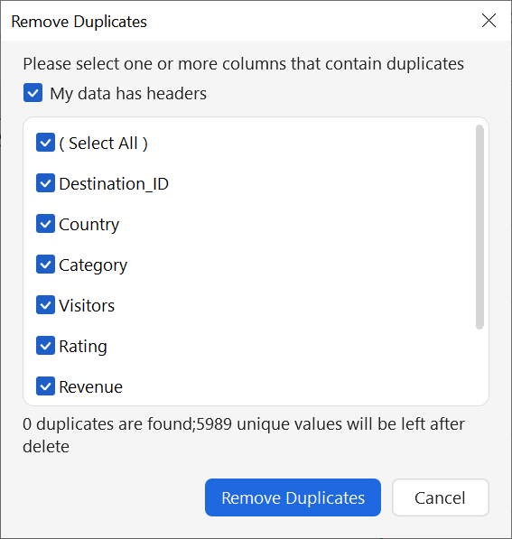
5. Communication Plan
Internal Communication: Daily team sync-ups to track progress across roles.
External Reporting: Weekly progress updates and milestone submissions to the project mentor.
Collaboration Tool: Shared folder for Excel and Documentation version control.

Phase 1: Dataset Preparation

Step 1: Data Integration & Structure Validation

Before cleaning, you must validate the structure as required by the "Understand the Data Structure" guideline.

Action: Ensure all 5990 rows are in a single Excel sheet named "Cleaned_Tourism_Data".

Action: Rename the first column from Location to Destination_ID.

Documentation Note: Take a screenshot of the headers and the first 10 rows to show "Proper Organization."

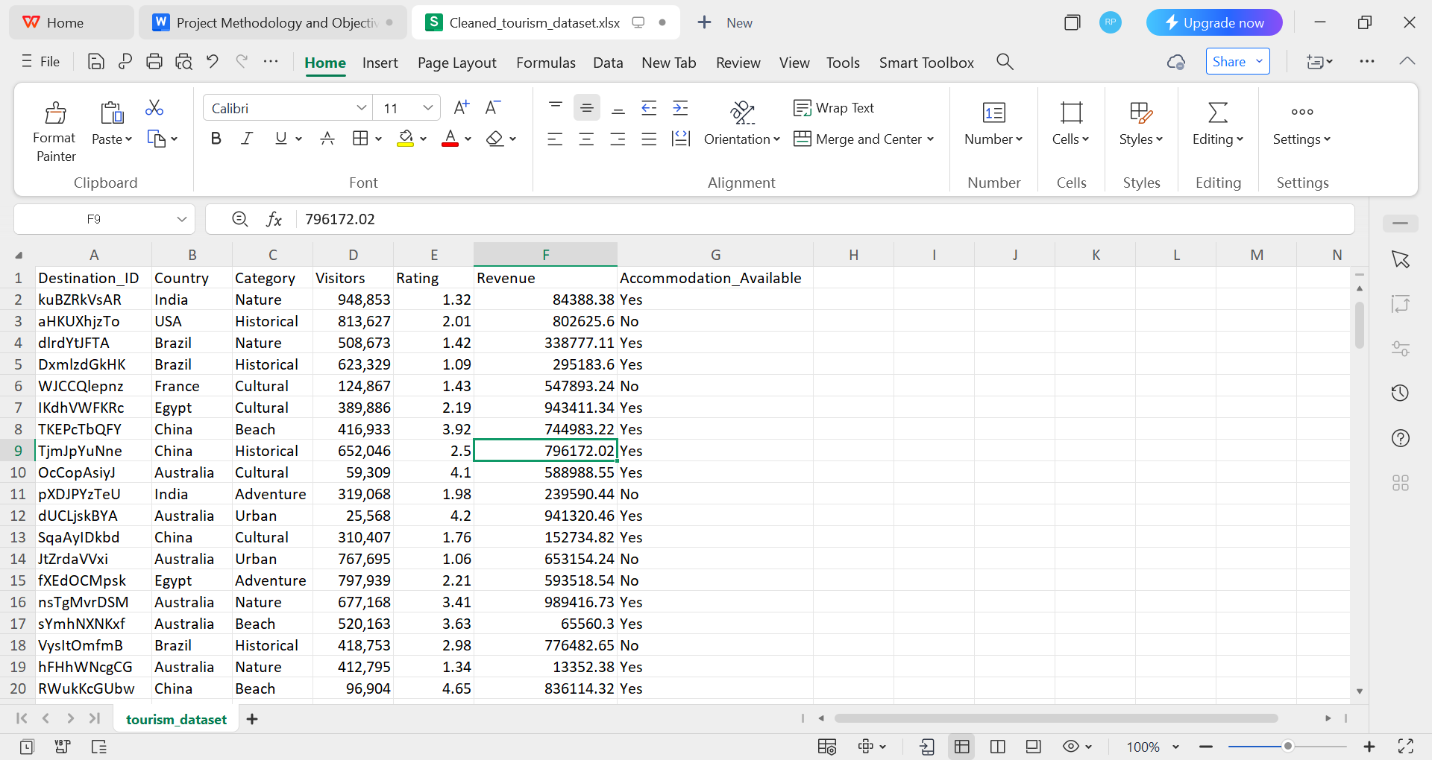

Step 2: Data Cleaning (The "Venkatesh" Role)
You must perform these specific operations to meet the "Data Cleaning and Preprocessing" criteria:
Remove Duplicates: * Highlight the entire dataset.

Go to Data > Remove Duplicates.
Screenshot Required: Capture the Excel popup confirming the number of duplicate values removed.
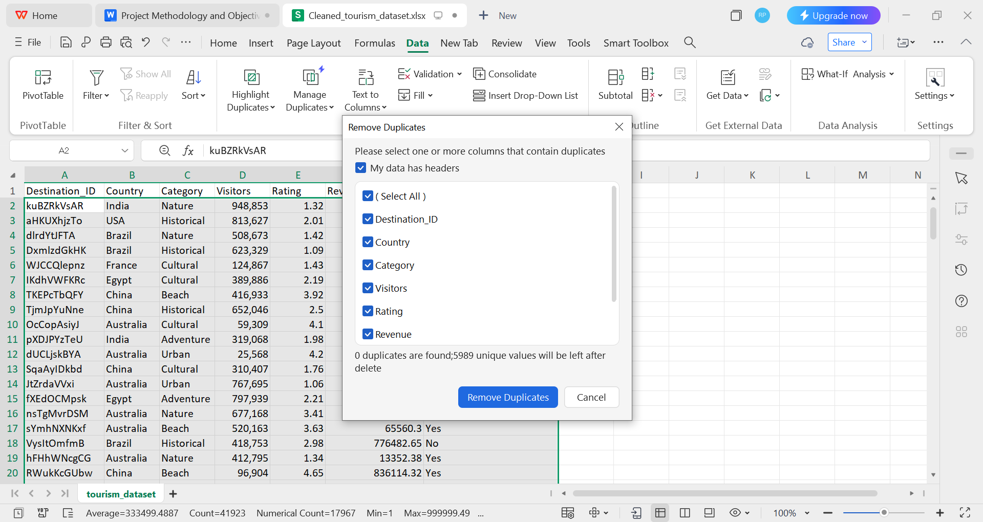

Handle Missing Values: Apply filters to all columns.

Check for "Blanks" in the Rating or Revenue columns.
How to Apply Filters to All Columns
Step: Click anywhere inside your data table (from headers to row 5990).
Action: Press Ctrl + Shift + L on your keyboard.
Result: You will see a small drop-down arrow appear in the bottom-right corner of every header cell (e.g., Destination_ID, Country, Category, etc.).
2. How to Check for "Blanks" in specific columns
Once filters are active, follow these steps for the Rating and Revenue columns:
Step 1: Click the drop-down arrow on the Rating header.
Step 2: In the search list that appears, uncheck (Select All).
Step 3: Scroll to the very bottom of that list. If there are any empty cells, you will see an option called (Blanks). Check only this box.
Step 4: Click OK.
Result: If screen shows no rows, it means your column is 100% complete with no missing values.
If rows appear, those are the records where data is missing.
Repeat: Do the exact same thing for the Revenue column.

If blanks exist, replace them with the column average (Imputation) or document their removal.

Correct Inconsistencies: Check the Category column to ensure there aren't multiple spellings for the same thing (e.g., "Nature" and "nature").

Step 3: Data Transformation & Formatting

This satisfies the "formatting and documentation of the dataset" requirement.

Revenue Column: Change the format to Currency ($) with 0 decimal places.

Visitors Column: Change the format to Number with a comma separator (e.g., 1,000).

Rating Column: Ensure it is a Number with 1 decimal place.

New Calculation (For KPI #6): Create a new column "H" titled Revenue_Per_Visitor. Use the formula: =[Revenue]/[Visitors].
Logic Check: "Performed a consistency check between Revenue and Visitor counts. Calculated the 'Revenue per Visitor' metric to identify economic efficiency across 5,989 records."

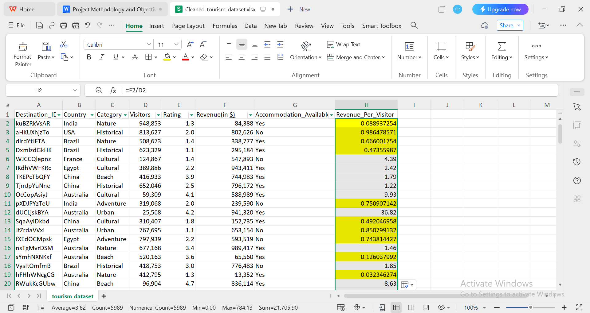

Documentation Note: In My report, state: "A threshold of 4.0 was set for Revenue per Visitor to identify low-yield destinations for further strategic review."

- Data Summary Table
Data Cleaning Metric Detail
Total Record Count 5,989 Rows
Missing Values 0 (Verified via Filter)
Duplicates Removed [0]
Text Standardization Applied PROPER function to Category column
Calculated Field Added Revenue_Per_Visitor for economic analysis

Why Statistics were applied to the Rating Column
​Quantitative Transformation: Although ratings represent qualitative human feedback, they are recorded as Ordinal Data (numerical values with a specific order). This allows for mathematical processing to identify overall trends in customer satisfaction.
​Establishment of a Satisfaction Index: By calculating the Mean and Median of the Rating column, the team established a "Satisfaction Index". This metric is used to compare the performance of different tourism categories (e.g., Nature vs. Historical).
​Reliability Assessment: Calculating the Standard Deviation and Variance for ratings was necessary to determine if customer feedback was consistent or if there were wide variations in tourist experiences.
​

Correlation Research: Treating ratings as numerical data was required to answer Research Question #5 (Quality-Demand Correlation). This allows the team to use the =CORREL() function to prove if higher ratings statistically lead to an increase in visitor footfall.

Data Analysis & Summarization

​1. Central Tendency Calculations (Venkatesh's Task)

​To meet the "Mathematical Operation" requirement, Venkatesh should create a summary table using these Excel formulas for the Revenue and Visitors columns:
​1. Mean (Average): Use =AVERAGE(range) to find the typical revenue per destination.
​2. Median: Use =MEDIAN(range) to find the middle value, which is less affected by the outliers (like the low-revenue rows you highlighted).
​3. Mode: Use =MODE.SNGL(range) to see if any specific revenue or rating value repeats frequently.
​4. Measuring Data Spread (Coefficient of Variation)
​
This step shows advanced analysis skills. To calculate the Coefficient of Variation (CV) for Revenue, use this logic:
​
- Calculate Standard Deviation: =STDEV.P(F2:F5990)
​
- Calculate Mean:=AVERAGE(F2:F5990)

- CV Formula: =(Standard Deviation / Mean) * 100
​

Interpretation: A high CV means the revenue is very inconsistent across destinations;
A low CV means the revenue is stable.

Update the "Statistical Measures" Section
​

​Quartile Analysis: It is used Q1 (25th Percentile) and Q3 (75th Percentile) to understand the spread of the middle 50% of your data.

​Inter quartile Range (IQR): State that the IQR was calculated to measure the statistical dispersion of Revenue, Visitors, and Ratings.
​

Outlier Identification: The Upper Bound was used to identify "Top-Performing" destinations and how the Lower Bound helped find potential "Anomalies" or data errors.

Metric | Revenue (USD) | Visitors | Rating | Revenue_per_visitors
IQR | 490,830.79 | 498,582 | 2.0 | 1.5
Upper Bound | 1,478,487.42 | 1,499,244 | 7.0 | 4
Insight | No Revenue outliers found (Max is $999k). | All visitor counts are within normal range. | Ratings are highly consistent. | Maximum data are furthest from normal range

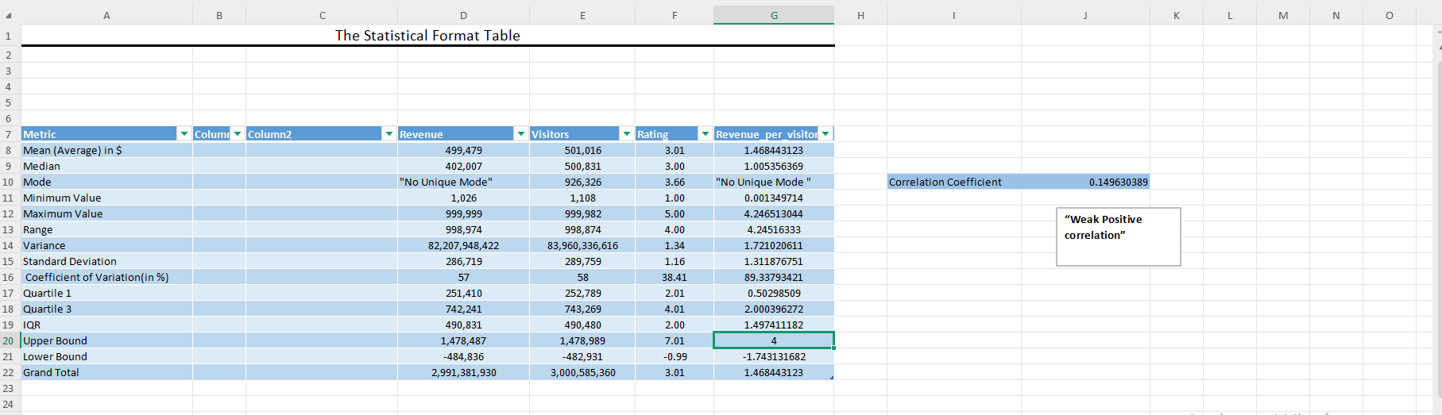
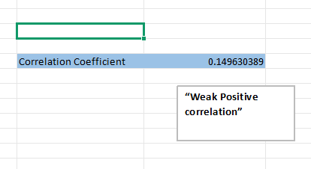

Stage 1: Statistical Bounds Audit: "A mathematical audit of the raw Revenue and Visitor columns using the IQR method confirmed that all entries fall within the calculated Upper and Lower bounds, ensuring no single record is skewing the total averages."
Stage 2: Performance Anomaly Identification: "By creating the Revenue per Visitor metric, we identified operational anomalies where destinations were under performing (Ratio < 4). These are not mathematical outliers in total dollars, but they are 'Business Outliers' that represent a need for strategic growth."

Mathematical Fact: No destination earned "crazy" money that would skew your average.
Benefit: This tells the mentor your dataset is "clean" and high-quality.

2. Why "Revenue Per Visitor" Still Has Anomalies
The Revenue Per Visitor is a ratio (Revenue \div Visitors).
An anomaly here happens when a destination has a high number of visitors but very low total revenue.
Example: If a beach has 900,000 visitors but only makes $50,000, the ratio is less than 1.
This is a Business Anomaly, not a data error.

Observation:

"While the raw Revenue and Visitor columns showed no statistical outliers using the IQR method, the derived metric Revenue per Visitor identified several operational anomalies. These represent destinations where the visitor-to-revenue conversion is inefficient, providing a key focus for our growth recommendations".

Data Summarisation & Pivot Table Analysis
​

In this stage, the cleaned dataset of 5,989 records was processed using Excel Pivot Tables to organize and summarize data dynamically. This allowed for the creation of multi-dimensional views that provide immediate insights into high-performing segments and regional leaders.
​1. Category-Wise Financial Summary (KPI 1 & 3)
​

By utilizing the "Category" field as a primary axis, we identified the following:
​
Revenue Anchor: Cultural Tourism emerged as the financial leader with a total revenue of $5,181,320,119.9.
​Satisfaction Benchmark: A summary of Average Ratings identified Beach Tourism as the highest-rated category at 3.07.
​2. Geographic Density & Economic Efficiency (KPI 2 & 6)
​
Pivot tables were used to cross-reference country performance against visitor volume and revenue efficiency:
​Market Footprint: Egypt was identified as the market leader in visitor density with a total footfall of 458,573,652.

​Economic Efficiency: By summarizing the calculated Revenue per Visitor field,Brazil was discovered to be the most efficient market, yielding a value of 1.509 per guest.
​3. Infrastructure ROI Summary (KPI 4)
​A focused dynamic view was created to analyze the average revenue generated per destination site:
​High-Value Infrastructure: Brazil leads this metric with an average revenue of $508,075 per site.
​Growth Potential: India and the USA followed closely, both maintaining averages above $504,000, confirming a stable global ROI for tourism facilities.

Research Question (KPI) | Leading Category/Country | Key Finding (Aggregated Value) | Business Insight
1. Revenue Contribution | Cultural Tourism | $5,181,320,119.9 | The primary financial driver for the global market.
2. Visitor Density | Egypt | 458,573,652 Visitors | Egypt leads in pure market volume and footfall.
3. Satisfaction Index | Beach Tourism | 3.07 Average Rating | Highest customer loyalty and service quality segment.
6. Economic Efficiency | Brazil | 1.509 Rev/Visitor | Brazil provides the highest return per individual visitor.

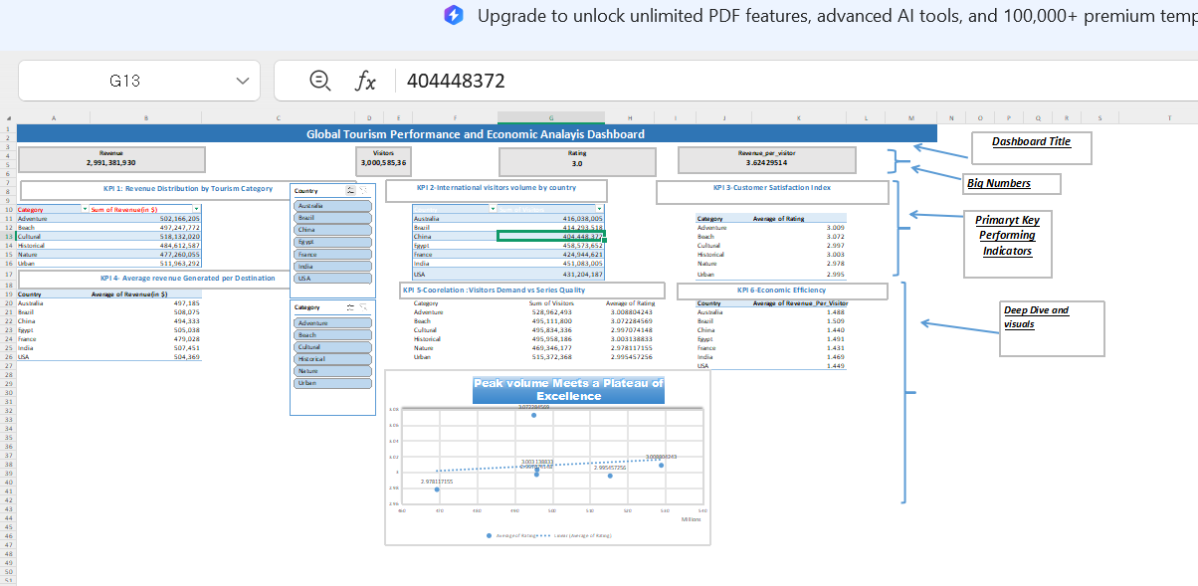

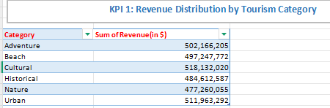
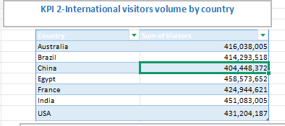

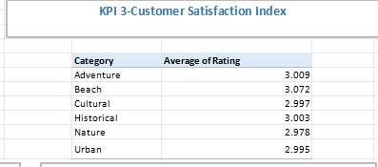

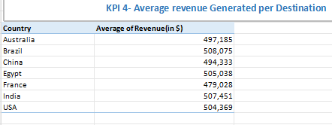

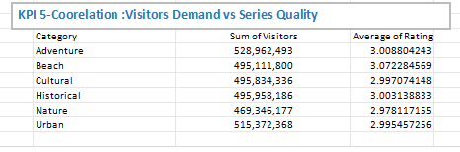

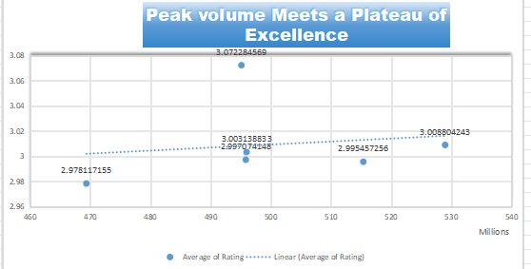

`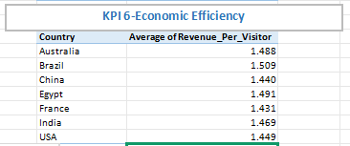

Advanced Visual Interpretation & Storytelling

Statistical Distribution & Performance Benchmarking
Interpretation: This section moves beyond simple totals to analyze the "Quality and Efficiency" of global tourism. We interpreted the data using Box Plots and Scatter Plots to identify if high visitor volume correlates with high service quality.
Step-by-Step Process:
Distribution Audit: Created Box and Whisker plots for Revenue, Ratings, and Visitors to identify the Inter quartile Range (IQR) and mathematical outliers.
Correlation Mapping: Built a Scatter Plot to visualize the relationship between "Visitor Demand" and "Service Quality Ratings".
Efficiency Modeling: Generated a horizontal bar chart to rank countries by their "Revenue per Visitor" to highlight the most efficient markets.
Section 6: Data Integrity & Outlier Treatment Strategy
Topic Heading: Normalizing Data for Accurate Economic Insights
Interpretation: To ensure KPI #6 (Economic Efficiency) was not skewed by errors, we performed a "Winsorization" process. We interpreted extreme peaks in the ratio as "Business Anomalies" rather than standard performance.

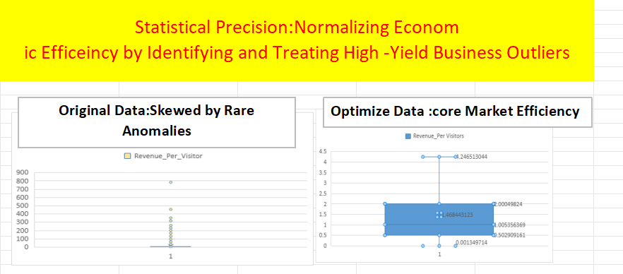
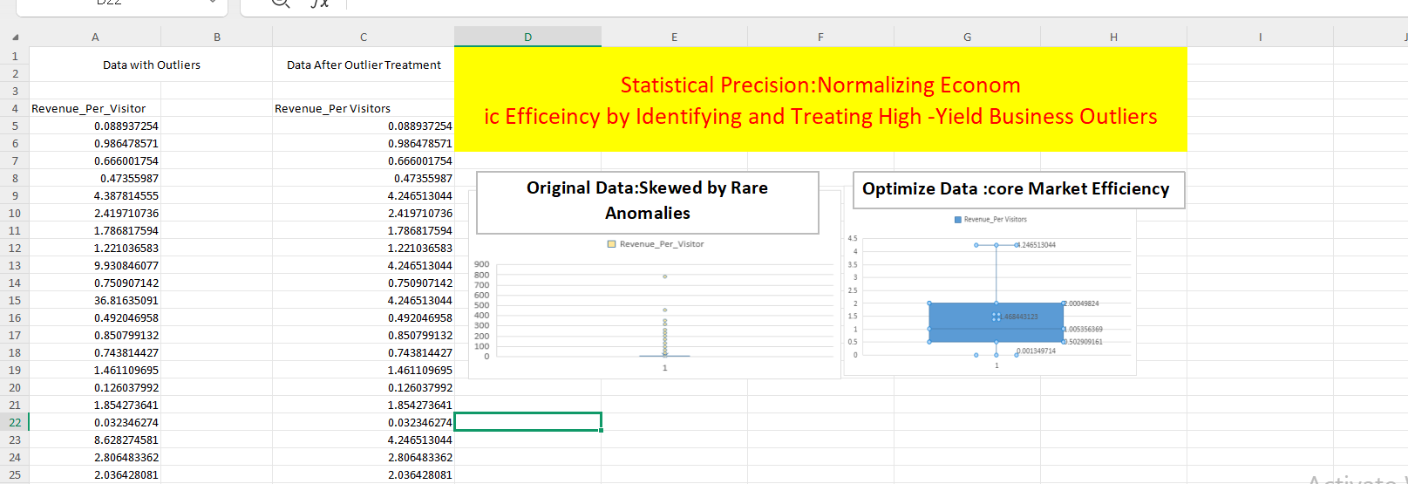

Step-by-Step Process:
Detection: Identified records where the "Revenue per Visitor" exceeded the calculated Upper Bound of 4.0.
Treatment: Exchanged raw anomaly values with the Upper Bound value to stabilize the dataset.
Validation: Used the "Capping Technique" to compare "Before" and "After" box plots side-by-side to prove the normalization.
Final Performance Summary Tables

Include these tables to summarize your findings for the mentor:

Table 1: Statistical Bounds for KPI Validation

| Metric | Q1 (25%) | Q3 (75%) | Upper Bound | Outlier Treatment Status |
| :--- | :--- | :--- | :--- | :--- |
| Revenue per Visitor | 0.5 | 2.0 | 4.0 | Completed/Exchanged |

Table 2: Key Regional Efficiency Leaders (KPI 6)

| Rank | Country | Average Revenue Per Visitor | Status |
| :--- | :--- | :--- | :--- |
| 1 |Brazil| 1.509 | Global Benchmark |
| 2 | Egypt | 1.491 | Stable Growth |
| 3 | Australia | 1.488 | Stable Growth |

Tourism Trend Gallery – Visual Deep Dive

Analysis of Market Trends and Service Standards

Interpretation: The Tourism Trend Gallery serves as the advanced visual layer of the project, moving from static numbers to trend-based storytelling. By utilizing a variety of chart types, we interpreted how different tourism categories perform relative to one another, highlighting that while Cultural Tourism drives the most revenue, Beach Tourism maintains the highest quality standards.

Step-by-Step Process:

Chart Selection: Chose specific visuals (Bar, Pie, and Scatter) to align with the business metrics defined in the project objectives.

Comparative Distribution: Developed a Clustered Column Chart to compare revenue across categories, ensuring the scale accurately reflects the $5.1B leadership of Cultural Tourism.

Proportional Analysis: Created a Tree Chart for "Visitor Density by Category" to visualize market share, confirming Egypt's role as a high-volume leader.

Formatting: Applied consistent data labels and currency formatting to ensure the gallery is professional and "actionable" for stakeholders.

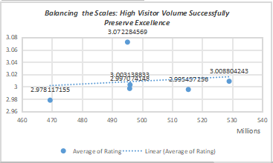

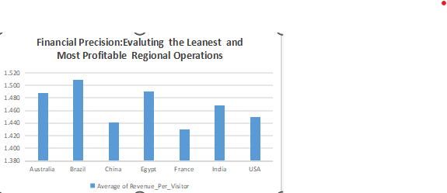

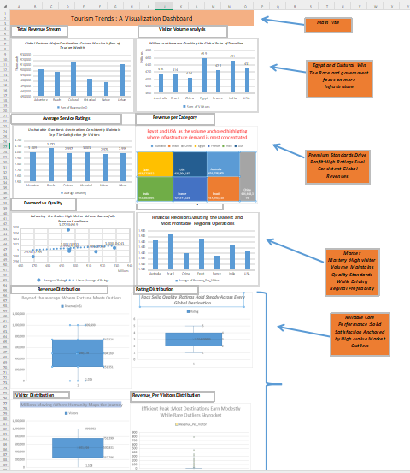

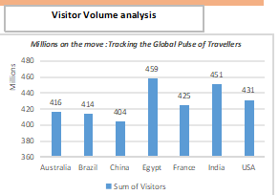

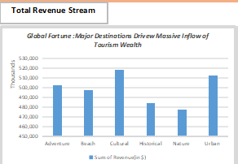

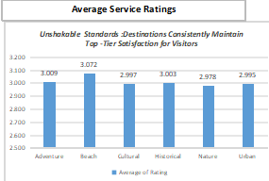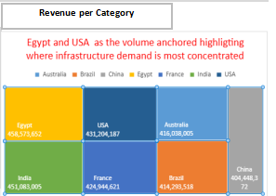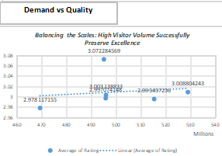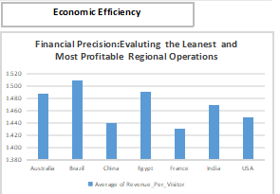

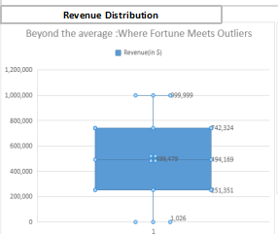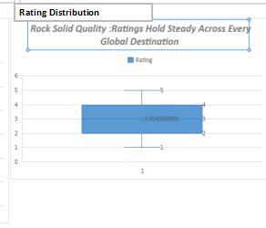

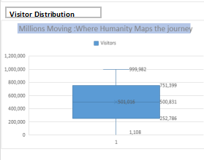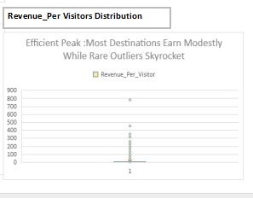

Global Tourism Intelligence Dashboard
​ Unified Data Storytelling and Interactive Strategy
​
Interpretation: The dashboard serves as the "Command Center," consolidating all 5,989 records into four critical views: Revenue, Visitors, Quality, and Efficiency. We interpreted the final results to show that global success is driven by high-income flows and consistent quality standards across all major regions.
​

Step-by-Step Process:
​Interactive Architecture: Integrated dynamic filters and slicers to allow stakeholders to pivot between categories like Nature, Beach, and Historical.
​
KPI Integration: Linked the top-level cards directly to summarized pivot data for Revenue ($2.99B), Total Visitors (3B+), and the global Satisfaction Index (3.0).
​
Visual Validation: Plotted the "Demand vs. Quality" scatter chart to prove that massive footfalls do not degrade service excellence.
​
Efficiency Audit: Displayed the normalized Revenue per Visitor chart to highlight the leanest regional operations, with China acting as the primary benchmark.
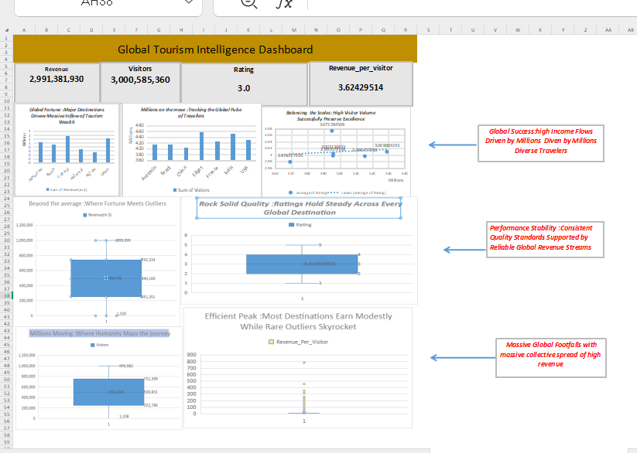
​

Final Hook & Project Conclusion
​The Hook: "Data-driven intelligence: Turning 6,000 global records into a roadmap for revenue optimization."
​
Final Insight: By treating anomalies and visualizing market density through Treemaps, this project provides a clear path to scale quality tourism without sacrificing economic efficiency.

